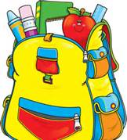
Imagine Klepinger Commmunity School

3rd Grade Supply List

2013-2014

6 –packs of 24 pencils

3- large pink erasers

Pack of pencil top erasers

4- glue sticks

1 bottle of white glue

3- boxes of 24 crayons

1 pair of scissors

1 School box

1 book bag

4- packs of wide ruled notebook paper

5- sprial notebooks , solid colors, wide ruled

5- plastic folders with pockets and prongs, solid colors

2 -1 inch white binders

2 packs of divder tabs

1 pack of 4 dry eraser markers

3 packs of index cards, white, 3x5, lined

2- boxes of tissues

2- Large bottles of hand sanitizer

Large roll of paper towels

2- containers of Clorox or Lyso wipes

1 Box of gallon size ziplock baggies (boys)

1 Box of quart size ziplock baggies (girls)

